Author Guidelines for 3DTV-CON 2018 Proceedings
Author(s) Name(s)
Author Affiliation(s)

Abstract
The abstract should appear at the top of the left-hand column of text, about 24 mm (1 inch) below the title area and no more than 80 mm (3.125 inches) in length. Leave a 12 mm (0.5 inch) space between the end of the abstract and the beginning of the main text. Abstract uses the same font as the main text (9-point Times New Roman). The abstract should contain about 100 to 150 words, and should be identical to the abstract text submitted electronically along with the paper cover sheet. All manuscripts must be in English. Enter up to 10 keywords separated by commas. Use bold Times New Roman 9-point italics for “Index terms” and standard font for the terms.
Index Terms — One, two, three, four, five, six, seven, eight, nine, ten
- Introduction
These guidelines include complete descriptions of the fonts, spacing, and related information for producing your proceedings manuscripts. Please follow them.
You are allowed a total of 4 pages for your document. This is the maximum number of pages that will be accepted, including all figures, tables and references. Any documents that exceed the 4 page limit will be rejected.
- Formatting your paper
Documents should be formatted for standard A4-size (210 mm x 297 mm or 8.3 inch x 11.7 inch) paper. All printed material, including text, illustrations, and charts, must be kept within a print area of 172 mm (6.77 inches) wide by 235 mm (9.25 inches) high. Do not write or print anything outside the print area. The top margin must be 25 mm (1 inch), except for the title page (32 mm or 1.26 inches), and the left margin must be 19 mm (0.75 inch). All text must be in a two-column format. Columns are to be 83 mm (3.27 inches) wide, with a 6 mm (0.25 inch) space between them. Text must be fully justified.
If the last page of your paper is only partially filled, arrange the columns so that they are evenly balanced if possible, rather than having one long column.
- Page title section
The paper title (on the first page) should begin 32 mm (1.26 inches) from the top edge of the page, centered, completely capitalized, and in Times New Roman 14-point, boldface type. Do not use non-Unicode characters in the title and avoid using uncommon acronyms.
The authors’ name(s) and affiliation(s) appear below the title in capital and lower case letters with author names in italics and affiliations in standard 12-point fonts. Papers with multiple authors and affiliations may require two or more lines for this information. The order of the authors on the document should match exactly in number and order the authors typed into the submission form.
- Type-style and fonts
To achieve the best rendering both in the proceedings and from the USB-stick, use Times New Roman font. In addition, this will give the proceedings a more uniform look. Use a font that is no smaller than nine point type throughout the paper, excluding figure captions.
In nine point type font, capital letters are 2 mm high. If you use the smallest point size, there should be no more than 3.2 lines/cm (8 lines/inch) vertically. This is a minimum spacing; 2.75 lines/cm (7 lines/inch) will make the paper much more readable. Larger type sizes require correspondingly larger vertical spacing. Please do not double-space your paper. True-Type 1 fonts are preferred.
The first paragraph in each section should not be indented, but all following paragraphs within the section should be indented by 6.3 mm (0.25 inch) as these paragraphs demonstrate.
- MAjor headings
Major headings, for example, “1. Introduction”, should appear in all capital letters, 9-point bold face, centered in the column, with 5 mm (0.2 inch) blank space before, and 5 mm (0.2 inch) blank space after. Use a period (“.”) after the heading number, not a colon.
  - Subheadings
Subheadings should appear in lower case (initial word capitalized) in 9-point boldface. They should start at the left margin on a separate line with 5 mm (0.2 inch) blank space before and after.
    - Sub-subheadings
Sub-subheadings, as in this paragraph, are discouraged. However, if you must use them, they should appear in lower case (initial word capitalized) and start at the left margin on a separate line, with 5 mm (0.2 inch) blank space before and the paragraph text beginning on the following line. They should be in 9-point italics.
- Page numbering
Please do not paginate your paper. Page numbers, session numbers, and conference identification will be inserted when the paper is included in the proceedings.
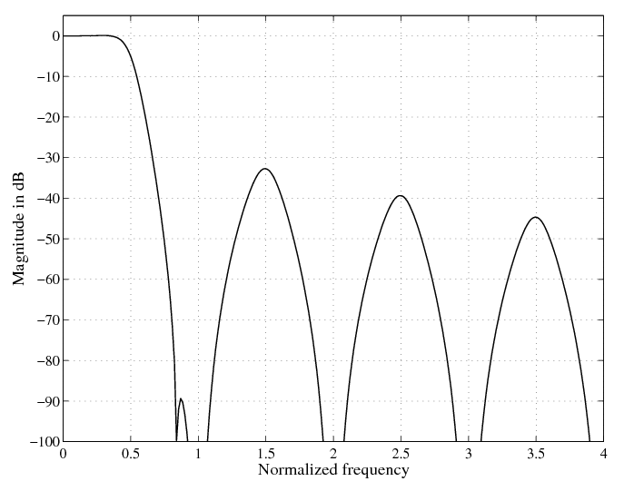
Figure 1. Example figure
- Illustrations, graphs, and photographs
Illustrations must appear within the designated margins. They may span the two columns. If possible, position illustrations at the top of columns, rather than in the middle or at the bottom. Caption and number every illustration. Remember to use the term “Figure N”' in both the caption and when it is referred in the main text, e.g. Figure 1. Use centered 8-point Times New Roman standard font for the captions.
Illustrations can contain colors. Since the proceedings will usually be printed without colors by the readers, please make sure your images are also acceptable when printed in black and white.
- Footnotes and references
Use footnotes sparingly (or not at all!) and place them at the bottom of the column on the page on which they are referenced. Use Times New Roman 9-point type, single-spaced. To help your readers, avoid using footnotes altogether and include necessary peripheral observations in the text (within parentheses, if you prefer, as in this sentence).
List and number all references at the end of the paper. The references can be numbered in alphabetic order or in order of appearance in the document. When referring to them in the text, type the corresponding reference number in square brackets as shown at the end of this sentence [1]. Examples of how to refer to a book [2], a journal paper [3], or a conference paper [1] are given in the reference list.
- Copyright forms
For camera-ready submissions, additional information is available at the conference website at http://www.3dtv-con.org/.
- References
- T. Tietelö, T. Taittaja, and G. G. Guru, “A typical conference paper,” in Proc. Some Int. Scientific Conf., Asker, Norway, Sep. 1999, pp. 123456–123459.
- P. O. Proffa, A Good DSP Book. NY: Publishing Company, New York, 1975.
- W. W. Wiseguy and D. Argh, “An important paper,” IEEE Trans. Signal Processing, vol. 99, pp. 9932–9948, Dec. 1988.

